

**JAVA MINI PROJECT**

**(Progress Report)**

**QUIZ APP**

Aditi Goyal (003)

Sri Venkata Neelima Chinta (070)

Arundarasi Rajendran (081)

## **Table of Contents**

### Introduction

1.1 Abstract.

1.2 Progress.

1. Project Progression

2.1 Screenshots of Progress & Code Snippets.

1. Individual Efforts

**Introduction:**

**Abstract**

This project is a simple offline quiz app with four quizzes and features like a leader board and basic GUI for the app. The questions are about food, general knowledge, marvel, and advertisements. The leaderboard is supported by the database to store the scores for different players who played the quiz. The database will help determine the highest scorer of the quiz.

**Progress**

The team has finished working on the basic quiz part of the code which is entering the quizzes and making functions for printing the questions and calculating the scores. We’ve also started our work on the leaderboard part for which we decided to use SQL and PHP to create the database. We have invested a lot of the time given to us into learning new things like database management using SQL and PHP, and GUI using AWT and Swing. We’ve still got a lot to learn, however we have now started working on both things and they are under development right now.

Hence, we decided to just add the snippets of the basic functioning code of our project.

**Project Progression:**

**Screenshots of progress & Code snippets**

Before starting our work on the GUI, we made a simple archetype code using no gui. This simply provided us with a perspective on what we have to achieve using gui, i.e how to make the code more user interactive.

Stage 1 :

Understanding different ways to make the program to be more user interactive, by making a basic java code and finding what difficulties are faced by a user while interacting with the program.

class Question

{

String prompt;

String answer;

public Question(String prompt, String answer)

{

this.prompt = prompt;

this.answer = answer;

}

}

//components of main class

class App

public static void takeTest(Question [] questions)

{

int score = 0;

Scanner sc = new Scanner(System.in);

for(int i=0;i<questions.length;i++)

{

System.out.println(questions[i].prompt);

String answer = sc.next();

if(answer.equals(questions[i].answer))

{

score++;

}

}

System.out.println("You got "+score+"/"+questions.length);

}

System.out.println("Choose the quiz you want to take\n"+"a) Brain teasers\nb) Avengers\nc) Indian Food\nd) Indian Advertisements\n");

String choice = sc.next();

switch(choice)

{

case "a":

takeTest(brain);

break;

case "b":

takeTest(marvel);

break;

case "c":

takeTest(food);

break;

case "d":

takeTest(ads);

break;

}}

Flow of program:

1. Ask user for a username
2. Ask the user which genre would they like to be quizzed
3. Get the genre and ask User with 10 Questions
4. The User will have to answer the 10 questions with appropriate options.
5. Calculate the result of the Quiz and show the user their score.
6. End.

OUTPUT of Step 1:

Getting user name and genre.

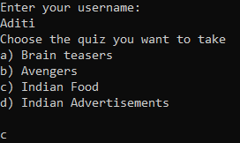

After step 1 the questions come in

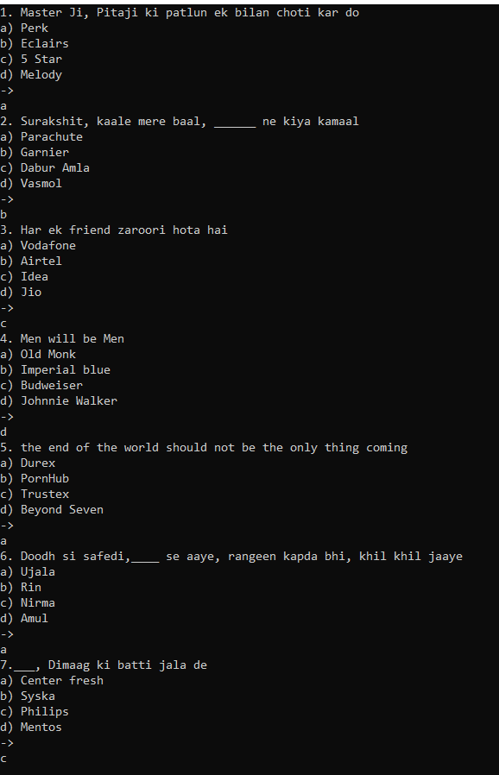

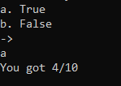

After all the questions are answered the user will be given their score.

Stage 2:

Using GUI to make the Quiz more interactive with the user.

Code:

import java.awt.*;

import java.applet.*;

class Frame1 extends Applet{

public static void main(String args[]){

Frame f = new Frame("WELCOME TO THE QUIZZ!!");

Label l1 = new Label("Enter your player name :");

l1.setBounds(150,100,200,40);

TextField t = new TextField("Username");

t.setBounds(120,155,200,30);

Button b = new Button("Next-->");

b.setBounds(300,300,100,30);

f.add(t);

f.add(b);

f.add(l1);

f.add(l2);

f.setSize(500,400);

f.setLayout(null);

f.setVisible(true);

}

}

The function added to the button next is that when the player clicks on it, another frame will be created that has the quiz topics. All the other frames are still under development, hence not attached here.

Output:

This will be the frame that will interact with the user and make the program more user friendly.

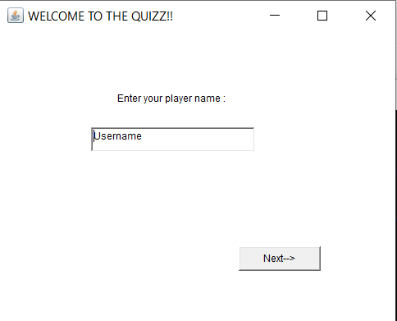

Format for all the Quizzes

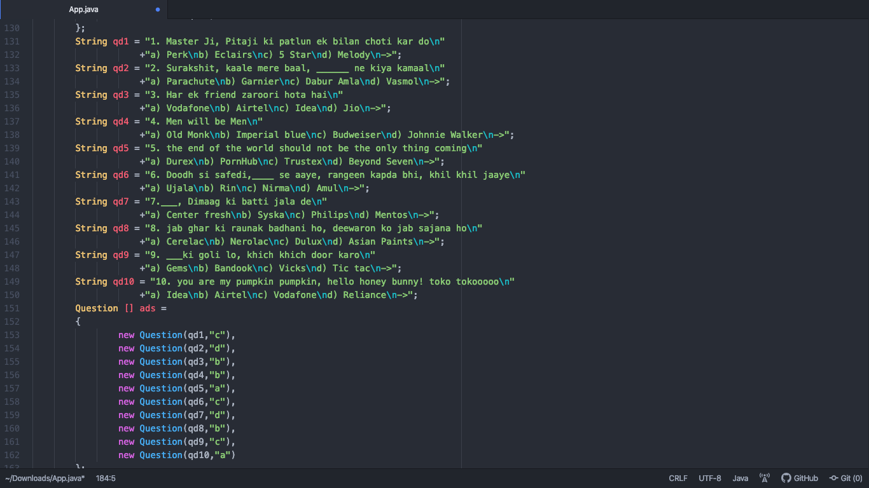

**Individual Efforts:**

* Aditi Goyal (003)

Basic Code and UI (AWT, Swing)

* Sri Venkata Neelima Chinta (070)

Database for leaderboard (SQL,PHP)

* Arundarasi Rajendran (081)

Quizzes and UI (AWT, Swing)